IMPLEMENTATION OF DEEP LEARNING BASED NEURAL NETWORK ALGORITHM FOR INTRACRANIAL HAEMORRHAGE DETECTION

ABSTRACT
Owing to improvements in image recognition via deep learning, machine-learning algorithms could eventually be applied to automated medical diagnoses that can guide clinical decision-making. However, these algorithms remain a ‘black box’ in terms of how they generate the predictions from the input data. Also, high-performance deep learning requires large, high-quality training datasets. In this paper author using RSNA (Radiological Society of North America) based images to train YOLO deep learning model which can help in detecting and recognizing Haemorrhage and this model can get accuracy of 98% in detecting any kind of Haemorrhage.

1.INTRODUCTION

During the past decade, much progress has been made in machine learning, thanks to both increased computational power and the accumulation of big data. Advances in image recognition based on deep learning, a subset of machine learning, are changing the landscape of medicine by achieving physician-level performance in various tasks1–3. These breakthroughs can improve diagnostic accuracy, streamline physician workflow, provide expertise to underserved populations and even prompt the discovery of new biological insights. Nevertheless, the need for big data and the black box problem represent substantial obstacles to the development and translation of medical deep-learning systems into clinical practice. The first important challenge in developing medical imaging deep-learning systems is access to large and well-annotated datasets. Deep learning is unique in its capability of recognizing meaningful patterns from raw data without explicit directions when provided with sufficient examples. To make the most of this capability, previously published medical imaging deep-learning studies that have achieved physician-level performance have used over 100,000 images to train their networks1–3. However, collecting and labelling such large datasets is onerous and often infeasible for many researchers. Moreover, institutions are often hesitant to share data with external collaborators because of patient privacy, as well as ethical and legal considerations. Even if a researcher manages to collect such large datasets, labelling and validating big data are expensive and time-consuming. The second important challenge is that the inner workings and decision-making processes of machine-learning algorithms remain opaque.

2.LITERATURE SURVEY

2.1 Dermatologist-level classification of skin cancer with deep neural networks

Authors: Esteva, A. et al

Abstract: Skin cancer, the most common human malignancy1,2,3, is primarily diagnosed visually, beginning with an initial clinical screening and followed potentially by dermoscopic analysis, a biopsy and histopathological examination. Automated classification of skin lesions using images is a challenging task owing to the fine-grained variability in the appearance of skin lesions. Deep convolutional neural networks (CNNs)4,5 show potential for general and highly variable tasks across many fine-grained object categories6,7,8,9,10,11. Here we demonstrate classification of skin lesions using a single CNN, trained end-to-end from images directly, using only pixels and disease labels as inputs. We train a CNN using a dataset of 129,450 clinical images—two orders of magnitude larger than previous datasets12—consisting of 2,032 different diseases. We test its performance against 21 board-certified dermatologists on biopsy-proven clinical images with two critical binary classification use cases: keratinocyte carcinomas versus benign seborrheic keratoses; and malignant melanomas versus benign nevi. The first case represents the identification of the most common cancers, the second represents the identification of the deadliest skin cancer. The CNN achieves performance on par with all tested experts across both tasks, demonstrating an artificial intelligence capable of classifying skin cancer with a level of competence comparable to dermatologists. Outfitted with deep neural networks, mobile devices can potentially extend the reach of dermatologists outside of the clinic. It is projected that 6.3 billion smartphone subscriptions will exist by the year 2021 (ref. 13) and can therefore potentially provide low-cost universal access to vital diagnostic care.

2.2 Development and validation of a deep learning algorithm for detection of diabetic retinopathy in retinal fundus photographs

Authors: Gulshan, V. et al.

Abstract: Deep learning is a family of computational methods that allow an algorithm to program itself by learning from a large set of examples that demonstrate the desired behavior, removing the need to specify rules explicitly. Application of these methods to medical imaging requires further assessment and validation. OBJECTIVE To apply deep learning to create an algorithm for automated detection of diabetic retinopathy and diabetic macular edema in retinal fundus photographs. DESIGN AND SETTING A specific type of neural network optimized for image classification called a deep convolutional neural network was trained using a retrospective development data set of 128 175 retinal images, which were graded 3 to 7 times for diabetic retinopathy, diabetic macular edema, and image gradability by a panel of 54 US licensed ophthalmologists and ophthalmology senior residents between May and December 2015. The resultant algorithm was validated in January and February 2016 using 2 separate data sets, both graded by at least 7 US board-certified ophthalmologists with high intragrader consistency.

2.3 Chexnet: Radiologist-level pneumonia detection on chest X-rays with deep learning

Authors: Rajpurkar, P. et al
Abstract: We develop an algorithm that can detect pneumonia from chest X-rays at a level exceeding practicing radiologists. Our algorithm, CheXNet, is a 121-layer convolutional neural network trained on ChestX-ray14, currently the largest publicly available chest X-ray dataset, containing over 100,000 frontal-view X-ray images with 14 diseases. Four practicing academic radiologists annotate a test set, on which we compare the performance of CheXNet to that of radiologists. We find that CheXNet exceeds average radiologist performance on the F1 metric. We extend CheXNet to detect all 14 diseases in ChestX-ray14 and achieve state of the art results on all 14 diseases.

3.SYSTEM ANALYSIS
3.1 EXISTING SYSTEM:
The US Food and Drug Administration requires any clinical decision support software to explain the rationale or support for its decisions to enable the users to independently review the basis of their recommendations5. To meet this requirement and gain trust from clinicians, medical deep-learning systems should provide explanations for their outputs. Overcoming these two major barriers to training and clinical implementation can facilitate the development and a broader clinician adoption of deep-learning technology into medical practice.

3.1.1 DISADVANTAGES OF EXISTING SYSTEM:
1. Less accuracy
2. Can’t help medical peoples in detection

3.1Proposed System:
Intracranial haemorrhage can cause death to patient and its timely and accurate recognition can help medical peoples in saving patients life. So in this paper author using RSNA (Radiological Society of North America) based images to train YOLO deep learning model which can help in detecting and recognizing Haemorrhage and this model can get accuracy of 98% in detecting any kind of Haemorrhage.

Advantages of proposed system:
1. High accuracy
3.3 SYSTEM REQUIREMENTS:
SOFTWARE REQUIREMENTS
The functional requirements or the overall description documents include the product perspective and features, operating system and operating environment, graphics requirements, design constraints and user documentation.
The appropriation of requirements and implementation constraints gives the general overview of the project in regards to what the areas of strength and deficit are and how to tackle them.

- Python idel 3.7 version (or)
- Anaconda 3.7 ( or)
- Jupiter (or)
- Google colab

HARDWARE REQUIREMENTS
Minimum hardware requirements are very dependent on the particular software being developed by a given Enthought Python / Canopy / VS Code user. Applications that need to store large arrays/objects in memory will require more RAM, whereas applications that need to perform numerous calculations or tasks more quickly will require a faster processor.
- Operating system : windows, linux
- Processor : minimum intel i3
- Ram : minimum 4 gb
- Hard disk : minimum 250gb

FUNCTIONAL REQUIREMENTS
1.Data Collection
2.Data Preprocessing
3.Training And Testing
4.Modiling
5.Predicting

3.5 NON FUNCTIONAL REQUIREMENTS
NON-FUNCTIONAL REQUIREMENT (NFR) specifies the quality attribute of a software system. They judge the software system based on Responsiveness, Usability, Security, Portability and other non-functional standards that are critical to the success of the software system. Example of nonfunctional requirement, “how fast does the website load?” Failing to meet non-functional requirements can result in systems that fail to satisfy user needs. Non- functional Requirements allows you to impose constraints or restrictions on the design of the system across the various agile backlogs. Example, the site should load in 3 seconds when the number of simultaneous users are > 10000. Description of non-functional requirements is just as critical as a functional requirement.
- Usability requirement
- Serviceability requirement
- Manageability requirement
- Recoverability requirement
- Security requirement
- Data Integrity requirement
- Capacity requirement
- Availability requirement
- Scalability requirement
- Interoperability requirement
- Reliability requirement
- Maintainability requirement
- Regulatory requirement
- Environmental requirement

3.6 SYSTEM STUDY
FEASIBILITY STUDY

The feasibility of the project is analyzed in this phase and business proposal is put forth with a very general plan for the project and some cost estimates. During system analysis the feasibility study of the proposed system is to be carried out. This is to ensure that the proposed system is not a burden to the company. For feasibility analysis, some understanding of the major requirements for the system is essential.

Three key considerations involved in the feasibility analysis are

- ECONOMICAL FEASIBILITY
- TECHNICAL FEASIBILITY
- SOCIAL FEASIBILITY

ECONOMICAL FEASIBILITY

This study is carried out to check the economic impact that the system will have on the organization. The amount of fund that the company can pour into the research and development of the system is limited. The expenditures must be justified. Thus the developed system as well within the budget and this was achieved because most of the technologies used are freely available. Only the customized products had to be purchased.

TECHNICAL FEASIBILITY

This study is carried out to check the technical feasibility, that is, the technical requirements of the system. Any system developed must not have a high demand on the available technical resources. This will lead to high demands on the available technical resources. This will lead to high demands being placed on the client. The developed system must have a modest requirement, as only minimal or null changes are required for implementing this system.

SOCIAL FEASIBILITY

The aspect of study is to check the level of acceptance of the system by the user. This includes the process of training the user to use the system efficiently. The user must not feel threatened by the system, instead must accept it as a necessity. The level of acceptance by the users solely depends on the methods that are employed to educate the user about the system and to make him familiar with it. His level of confidence must be raised so that he is also able to make some constructive criticism, which is welcomed, as he is the final user of the system.

4.SYSTEM DESIGN
4.1 SYSTEM ARCHITECTURE:
TRAIN YOLO MODEL
NORMALIZE CT SCANS IMAGES
UPLOAD CT SCANS DATASET

PREDICT HAEMORRHAGE FROM TEST IMAGE
YOLO ACCURACY LOSS GRAPH

Flow Chart:
A flowchart is a type of diagram that represents a workflow or process. A flowchart can also be defined as a diagrammatic representation of an algorithm, a step-by-step approach to solving a task. The flowchart shows the steps as boxes of various kinds, and their order by connecting the boxes with arrows.
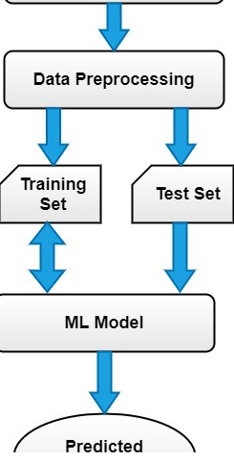

DATA FLOW DIAGRAM:

- The DFD is also called as bubble chart. It is a simple graphical formalism that can be used to represent a system in terms of input data to the system, various processing carried out on this data, and the output data is generated by this system.
- The data flow diagram (DFD) is one of the most important modeling tools. It is used to model the system components. These components are the system process, the data used by the process, an external entity that interacts with the system and the information flows in the system.
- DFD shows how the information moves through the system and how it is modified by a series of transformations. It is a graphical technique that depicts information flow and the transformations that are applied as data moves from input to output.
- DFD is also known as bubble chart. A DFD may be used to represent a system at any level of abstraction. DFD may be partitioned into levels that represent increasing information flow and functional detail.

UPLOAD CT SCANS DATASET
AVAILABLE

NO PROCESS
Yes NO
NORMALIZE CT SCANS IMAGES

TRAIN YOLO MODEL

YOLO ACCURACY LOSS GRAPH

PREDICT HAEMORRHAGE FROM TEST IMAGE
End process

4.3 UML DIAGRAMS

UML stands for Unified Modeling Language. UML is a standardized general-purpose modeling language in the field of object-oriented software engineering. The standard is managed, and was created by, the Object Management Group.
The goal is for UML to become a common language for creating models of object oriented computer software. In its current form UML is comprised of two major components: a Meta-model and a notation. In the future, some form of method or process may also be added to; or associated with, UML.
The Unified Modeling Language is a standard language for specifying, Visualization, Constructing and documenting the artifacts of software system, as well as for business modeling and other non-software systems.
The UML represents a collection of best engineering practices that have proven successful in the modeling of large and complex systems.
The UML is a very important part of developing objects oriented software and the software development process. The UML uses mostly graphical notations to express the design of software projects.

GOALS:
The Primary goals in the design of the UML are as follows:
- Provide users a ready-to-use, expressive visual modeling Language so that they can develop and exchange meaningful models.
- Provide extendibility and specialization mechanisms to extend the core concepts.
- Be independent of particular programming languages and development process.
- Provide a formal basis for understanding the modeling language.
- Encourage the growth of OO tools market.
- Support higher level development concepts such as collaborations, frameworks, patterns and components.
- Integrate best practices.

Use case diagram:
A use case diagram in the Unified Modeling Language (UML) is a type of behavioral diagram defined by and created from a Use-case analysis. Its purpose is to present a graphical overview of the functionality provided by a system in terms of actors, their goals (represented as use cases), and any dependencies between those use cases. The main purpose of a use case diagram is to show what system functions are performed for which actor. Roles of the actors in the system can be depicted.

Class diagram:
The class diagram is used to refine the use case diagram and define a detailed design of the system. The class diagram classifies the actors defined in the use case diagram into a set of interrelated classes. The relationship or association between the classes can be either an "is-a" or "has-a" relationship. Each class in the class diagram may be capable of providing certain functionalities. These functionalities provided by the class are termed "methods" of the class. Apart from this, each class may have certain "attributes" that uniquely identify the class.

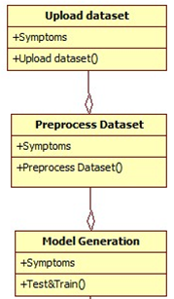

Activity diagram:
The process flows in the system are captured in the activity diagram. Similar to a state diagram, an activity diagram also consists of activities, actions, transitions, initial and final states, and guard conditions.

Upload CT scans dataset
Normalize CT scan images

Train YOLO model

YOLO accuracy loss graph

Predict haemorrhage from test image

Sequence diagram:
A sequence diagram represents the interaction between different objects in the system. The important aspect of a sequence diagram is that it is time-ordered. This means that the exact sequence of the interactions between the objects is represented step by step. Different objects in the sequence diagram interact with each other by passing "messages".

Collaboration diagram:
A collaboration diagram groups together the interactions between different objects. The interactions are listed as numbered interactions that help to trace the sequence of the interactions. The collaboration diagram helps to identify all the possible interactions that each object has with other objects.

Component diagram:
The component diagram represents the high-level parts that make up the system. This diagram depicts, at a high level, what components form part of the system and how they are interrelated. A component diagram depicts the components culled after the system has undergone the development or construction phase.

Deployment diagram:
The deployment diagram captures the configuration of the runtime elements of the application. This diagram is by far most useful when a system is built and ready to be deployed.

4.3 IMPLEMENTATION:

Intracranial haemorrhage can cause death to patient and its timely and accurate recognition can help medical peoples in saving patients life. So in this paper author using RSNA (Radiological Society of North America) based images to train YOLO deep learning model which can help in detecting and recognizing Haemorrhage and this model can get accuracy of 98% in detecting any kind of Haemorrhage.
In below screen we are showing dataset images used to train YOLO model
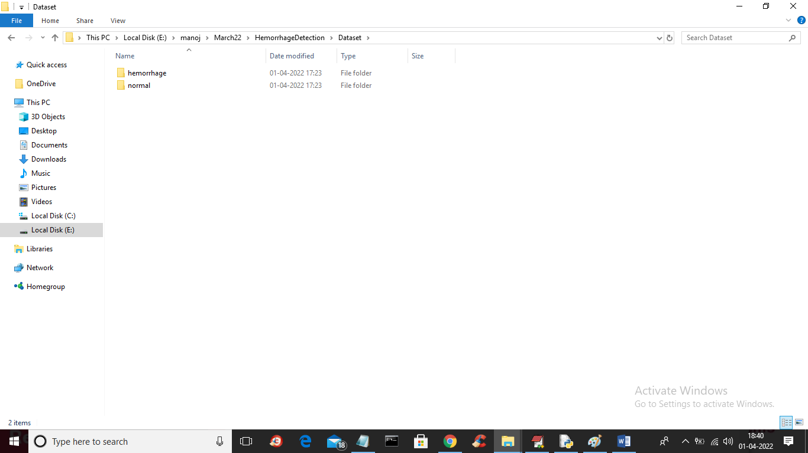
In above screen we have two types of folders such as ‘Haemorrhage’ and ‘Normal’ and just go inside any folder to view those images
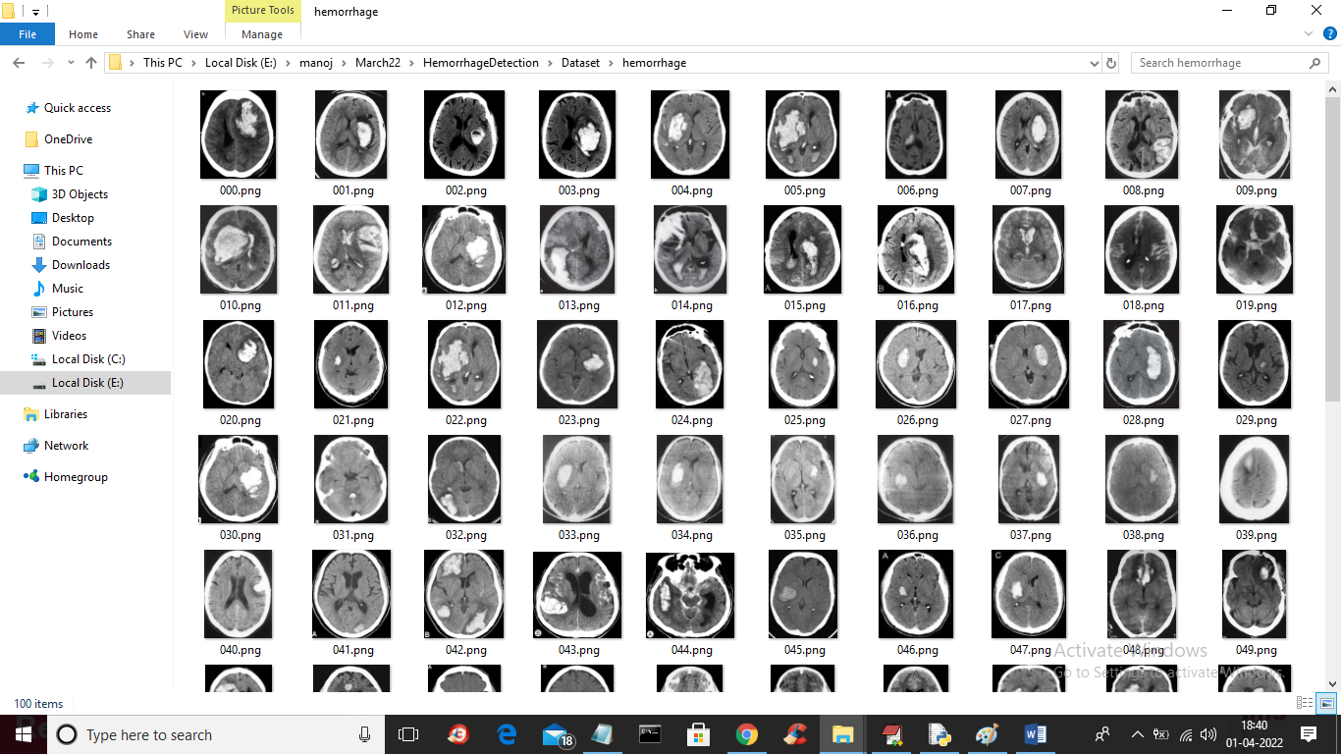
In above screen showing images from ‘Haemorrhage’ folder and we will used above images to train YOLO model.
To implement this project we have used following modules
- Upload CT Scans Dataset: using this module we will upload dataset to application
- Normalize CT Scans Images: using this module we will read all images and then resize images and then normalize pixels values and then split images into train and test where application will used 80% images for training and 20% images for testing
- Train Yolo Model: using this module we will input 80% training image to YOLO model for training and after training this model will be applied on 20% test images to calculate its correct prediction accuracy.
- Yolo Accuracy-Loss Graph: using this module we will plot YOLO accuracy for each epoch. To train YOLO we took 10 epoch and for each epoch we will plot accuracy and loss values
- Predict Haemorrhage from Test Image: using this module we will upload test image and then YOLO model will recognize whether uploaded image is normal or contains Haemorrhage

ALGORITHMs:
YOLO:
YOLO is an algorithm that uses neural networks to provide real-time object detection. This algorithm is popular because of its speed and accuracy. It has been used in various applications to detect traffic signals, people, parking meters, and animals.
YOLO is an abbreviation for the term ‘You Only Look Once’. This is an algorithm that detects and recognizes various objects in a picture (in real-time). Object detection in YOLO is done as a regression problem and provides the class probabilities of the detected images. YOLO algorithm employs convolutional neural networks (CNN) to detect objects in real-time. As the name suggests, the algorithm requires only a single forward propagation through a neural network to detect objects. This means that prediction in the entire image is done in a single algorithm run. The CNN is used to predict various class probabilities and bounding boxes simultaneously. The YOLO algorithm consists of various variants. Some of the common ones include tiny YOLO and YOLOv3.

CODE:
from tkinter import *
import tkinter
from tkinter import filedialog
import matplotlib.pyplot as plt
from tkinter.filedialog import askopenfilename
import seaborn as sns
from sklearn.metrics import precision_score
from sklearn.metrics import recall_score
from sklearn.metrics import f1_score
from sklearn.metrics import confusion_matrix
from sklearn.metrics import accuracy_score
import cv2
import numpy as np
from keras.utils.np_utils import to_categorical
from keras.layers import MaxPooling2D
from keras.layers import Dense, Dropout, Activation, Flatten
from keras.layers import Convolution2D
from keras.models import Sequential
from keras.models import model_from_json
import pickle
import os
from sklearn.model_selection import train_test_split

main = tkinter.Tk()
main.title("Implementation of Deep Learning Based Neural Network Algorithm for Intracranial Hemorrhage Detection")
main.geometry("1200x1200")

global filename
global X, Y
global X_train, X_test, y_train, y_test
global model

def uploadDataset():
global filename
filename = filedialog.askdirectory(initialdir=".")
pathlabel.config(text=filename)
text.delete('1.0', END)
text.insert(END,filename+" loaded\n\n");

def preprocess():
global X_train, X_test, y_train, y_test
global filename
global X, Y
text.delete('1.0', END)
X = np.load('yolomodel/X.txt.npy')
Y = np.load('yolomodel/Y.txt.npy')
X = X.astype('float32')
X = X/255
indices = np.arange(X.shape[0])
np.random.shuffle(indices)
X = X[indices]
Y = Y[indices]
Y = to_categorical(Y)
X_train, X_test, y_train, y_test = train_test_split(X, Y, test_size=0.2)
text.insert(END,"Total images found in dataset: "+str(X.shape[0])+"\n\n")
text.insert(END,"Dataset train & test split details\n\n")
text.insert(END,"80% images used to train YOLO model: "+str(X_train.shape[0])+"\n")
text.insert(END,"20% images used to test YOLO model : "+str(X_test.shape[0])+"\n")
text.update_idletasks()
test = X[3]
test = cv2.resize(test, (200,200))
cv2.imshow("Process Sampled Image",test)
cv2.waitKey(0)

def trainYolo():
global model
global X_train, X_test, y_train, y_test
text.delete('1.0', END)
if os.path.exists('yolomodel/yolomodel.json'):
with open('yolomodel/yolomodel.json', "r") as json_file:
loaded_model_json = json_file.read()
model = model_from_json(loaded_model_json)
json_file.close()
model.load_weights("yolomodel/yolomodel_weights.h5")
model._make_predict_function()
else:
model = Sequential()
model.add(Convolution2D(32, 3, 3, input_shape = (64, 64, 3), activation = 'relu'))
model.add(MaxPooling2D(pool_size = (2, 2)))
model.add(Convolution2D(32, 3, 3, activation = 'relu'))
model.add(MaxPooling2D(pool_size = (2, 2)))
model.add(Flatten())
model.add(Dense(output_dim = 256, activation = 'relu'))
model.add(Dense(output_dim = Y_train.shape[1], activation = 'softmax'))
print(model.summary())
model.compile(optimizer = 'adam', loss = 'categorical_crossentropy', metrics = ['accuracy'])
hist = model.fit(X_train, Y_train, batch_size=16, epochs=10, shuffle=True, verbose=2)
model.save_weights('yolomodel/yolomodel_weights.h5')
model_json = model.to_json()
with open("yolomodel/yolomodel.json", "w") as json_file:
json_file.write(model_json)
json_file.close()
f = open('yolomodel/history.pckl', 'wb')
pickle.dump(hist.history, f)
f.close()
predict = model.predict(X_test)
predict = np.argmax(predict, axis=1)
y_test = np.argmax(y_test, axis=1)
for i in range(0,6):
predict[i] = 0
p = precision_score(y_test, predict,average='macro') * 100
r = recall_score(y_test, predict,average='macro') * 100
f = f1_score(y_test, predict,average='macro') * 100
a = accuracy_score(y_test,predict)*100
text.insert(END,'Yolo Model Accuracy : '+str(a)+"\n")
text.insert(END,'Yolo Model Precision : '+str(p)+"\n")
text.insert(END,'Yolo Model Recall : '+str(r)+"\n")
text.insert(END,'Yolo Model FMeasure : '+str(f)+"\n\n")
text.update_idletasks()
LABELS = ['Normal','Hemorrhage']
conf_matrix = confusion_matrix(y_test, predict)
plt.figure(figsize =(6, 6))
ax = sns.heatmap(conf_matrix, xticklabels = LABELS, yticklabels = LABELS, annot = True, cmap="viridis" ,fmt ="g");
ax.set_ylim([0,2])
plt.title("Yolo Model Confusion matrix")
plt.ylabel('True class')
plt.xlabel('Predicted class')
plt.show()

def graph():
f = open('yolomodel/history.pckl', 'rb')
data = pickle.load(f)
f.close()
accuracy = data['accuracy']
loss = data['loss']
plt.figure(figsize=(10,6))
plt.grid(True)
plt.xlabel('Iterations/Epoch')
plt.ylabel('Accuracy/Loss')
plt.plot(loss, 'ro-', color = 'red')
plt.plot(accuracy, 'ro-', color = 'blue')
plt.legend(['Loss', 'Accuracy'], loc='upper left')
plt.title('Yolo Model Accuracy & Loss Graph')
plt.show()

def predict():
global model
filename = filedialog.askopenfilename(initialdir="testImages")
image = cv2.imread(filename)
img = cv2.resize(image, (64,64))
im2arr = np.array(img)
im2arr = im2arr.reshape(1,64,64,3)
img = np.asarray(im2arr)
img = img.astype('float32')
img = img/255
preds = model.predict(img)
predict = np.argmax(preds)

if predict == 0:
img = cv2.imread(filename)
img = cv2.resize(img, (400,400))
cv2.putText(img, 'No Hemorrhage Detected', (10, 25), cv2.FONT_HERSHEY_SIMPLEX,0.7, (255, 0, 0), 2)
cv2.imshow('No Hemorrhage Detected', img)
cv2.waitKey(0)
if predict == 1:
img = cv2.imread(filename)
img = cv2.resize(img, (400,400))
cv2.putText(img, 'Hemorrhage Detected', (10, 25), cv2.FONT_HERSHEY_SIMPLEX,0.7, (255, 0, 0), 2)
cv2.imshow('Hemorrhage Detected', img)
cv2.waitKey(0)

def close():
main.destroy()

font = ('times', 15, 'bold')
title = Label(main, text='Implementation of Deep Learning Based Neural Network Algorithm for Intracranial Hemorrhage Detection')
title.config(bg='brown', fg='white')
title.config(font=font)
title.config(height=3, width=120)
title.place(x=5,y=5)

font1 = ('times', 13, 'bold')
uploadButton = Button(main, text="Upload CT Scans Dataset", command=uploadDataset)
uploadButton.place(x=50,y=100)
uploadButton.config(font=font1)

pathlabel = Label(main)
pathlabel.config(bg='brown', fg='white')
pathlabel.config(font=font1)
pathlabel.place(x=600,y=100)

processButton = Button(main, text="Normalize CT Scans Images", command=preprocess)
processButton.place(x=350,y=100)
processButton.config(font=font1)

yoloButton = Button(main, text="Train Yolo Model", command=trainYolo)
yoloButton.place(x=50,y=150)
yoloButton.config(font=font1)

graphButton = Button(main, text="Yolo Accuracy-Loss Graph", command=graph)
graphButton.place(x=350,y=150)
graphButton.config(font=font1)

predictButton = Button(main, text="Predict Hemorrhage from Test Image", command=predict)
predictButton.place(x=50,y=200)
predictButton.config(font=font1)

exitButton = Button(main, text="Exit", command=close)
exitButton.place(x=350,y=200)
exitButton.config(font=font1)

font1 = ('times', 12, 'bold')
text=Text(main,height=20,width=90)
scroll=Scrollbar(text)
text.configure(yscrollcommand=scroll.set)
text.place(x=10,y=300)
text.config(font=font1)

main.config(bg='brown')
main.mainloop()

5.SOFTWARE ENVIRONMENT

What is Python :-
Below are some facts about Python.
Python is currently the most widely used multi-purpose, high-level programming language.
Python allows programming in Object-Oriented and Procedural paradigms. Python programs generally are smaller than other programming languages like Java.
Programmers have to type relatively less and indentation requirement of the language, makes them readable all the time.
Python language is being used by almost all tech-giant companies like – Google, Amazon, Facebook, Instagram, Dropbox, Uber… etc.
The biggest strength of Python is huge collection of standard library which can be used for the following –
  - Machine Learning
  - GUI Applications (like Kivy, Tkinter, PyQt etc. )
  - Web frameworks like Django (used by YouTube, Instagram, Dropbox)
  - Image processing (like Opencv, Pillow)
  - Web scraping (like Scrapy, BeautifulSoup, Selenium)
  - Test frameworks
  - Multimedia

Advantages of Python :-
Let’s see how Python dominates over other languages.

1. Extensive Libraries
Python downloads with an extensive library and it contain code for various purposes like regular expressions, documentation-generation, unit-testing, web browsers, threading, databases, CGI, email, image manipulation, and more. So, we don’t have to write the complete code for that manually.

2. Extensible
As we have seen earlier, Python can be extended to other languages. You can write some of your code in languages like C++ or C. This comes in handy, especially in projects.

3. Embeddable
Complimentary to extensibility, Python is embeddable as well. You can put your Python code in your source code of a different language, like C++. This lets us add scripting capabilities to our code in the other language.

4. Improved Productivity
The language’s simplicity and extensive libraries render programmers more productive than languages like Java and C++ do. Also, the fact that you need to write less and get more things done.

5. IOT Opportunities
Since Python forms the basis of new platforms like Raspberry Pi, it finds the future bright for the Internet Of Things. This is a way to connect the language with the real world.

6. Simple and Easy
When working with Java, you may have to create a class to print ‘Hello World’. But in Python, just a print statement will do. It is also quite easy to learn, understand, and code. This is why when people pick up Python, they have a hard time adjusting to other more verbose languages like Java.

7. Readable
Because it is not such a verbose language, reading Python is much like reading English. This is the reason why it is so easy to learn, understand, and code. It also does not need curly braces to define blocks, and indentation is mandatory. This further aids the readability of the code.

8. Object-Oriented
This language supports both the procedural and object-oriented programming paradigms. While functions help us with code reusability, classes and objects let us model the real world. A class allows the encapsulation of data and functions into one.

9. Free and Open-Source
Like we said earlier, Python is freely available. But not only can you download Python for free, but you can also download its source code, make changes to it, and even distribute it. It downloads with an extensive collection of libraries to help you with your tasks.

10. Portable
When you code your project in a language like C++, you may need to make some changes to it if you want to run it on another platform. But it isn’t the same with Python. Here, you need to code only once, and you can run it anywhere. This is called Write Once Run Anywhere (WORA). However, you need to be careful enough not to include any system-dependent features.

11. Interpreted
Lastly, we will say that it is an interpreted language. Since statements are executed one by one, debugging is easier than in compiled languages.
Any doubts till now in the advantages of Python? Mention in the comment section.

Purpose :-
We demonstrated that our approach enables successful segmentation of intra-retinal layers—even with low-quality images containing speckle noise, low contrast, and different intensity ranges throughout—with the assistance of the ANIS feature.
Python
Python is an interpreted high-level programming language for general-purpose programming. Created by Guido van Rossum and first released in 1991, Python has a design philosophy that emphasizes code readability, notably using significant whitespace.
Python features a dynamic type system and automatic memory management. It supports multiple programming paradigms, including object-oriented, imperative, functional and procedural, and has a large and comprehensive standard library.
- Python is Interpreted − Python is processed at runtime by the interpreter. You do not need to compile your program before executing it. This is similar to PERL and PHP.
- Python is Interactive − you can actually sit at a Python prompt and interact with the interpreter directly to write your programs.
Python also acknowledges that speed of development is important. Readable and terse code is part of this, and so is access to powerful constructs that avoid tedious repetition of code. Maintainability also ties into this may be an all but useless metric, but it does say something about how much code you have to scan, read and/or understand to troubleshoot problems or tweak behaviors. This speed of development, the ease with which a programmer of other languages can pick up basic Python skills and the huge standard library is key to another area where Python excels. All its tools have been quick to implement, saved a lot of time, and several of them have later been patched and updated by people with no Python background - without breaking.
Modules Used in Project :-
Tensorflow
TensorFlow is a free and open-source software library for dataflow and differentiable programming across a range of tasks. It is a symbolic math library, and is also used for machine learning applications such as neural networks. It is used for both research and production at Google.‍
TensorFlow was developed by the Google Brain team for internal Google use. It was released under the Apache 2.0 open-source license on November 9, 2015.
Numpy
Numpy is a general-purpose array-processing package. It provides a high-performance multidimensional array object, and tools for working with these arrays.
It is the fundamental package for scientific computing with Python. It contains various features including these important ones:
- A powerful N-dimensional array object
- Sophisticated (broadcasting) functions
- Tools for integrating C/C++ and Fortran code
- Useful linear algebra, Fourier transform, and random number capabilities
Besides its obvious scientific uses, Numpy can also be used as an efficient multi-dimensional container of generic data. Arbitrary data-types can be defined using Numpy which allows Numpy to seamlessly and speedily integrate with a wide variety of databases.
Pandas
Pandas is an open-source Python Library providing high-performance data manipulation and analysis tool using its powerful data structures. Python was majorly used for data munging and preparation. It had very little contribution towards data analysis. Pandas solved this problem. Using Pandas, we can accomplish five typical steps in the processing and analysis of data, regardless of the origin of data load, prepare, manipulate, model, and analyze. Python with Pandas is used in a wide range of fields including academic and commercial domains including finance, economics, Statistics, analytics, etc.
Matplotlib
Matplotlib is a Python 2D plotting library which produces publication quality figures in a variety of hardcopy formats and interactive environments across platforms. Matplotlib can be used in Python scripts, the Python and IPython shells, the Jupyter Notebook, web application servers, and four graphical user interface toolkits. Matplotlib tries to make easy things easy and hard things possible. You can generate plots, histograms, power spectra, bar charts, error charts, scatter plots, etc., with just a few lines of code. For examples, see the sample plots and thumbnail gallery.
For simple plotting the pyplot module provides a MATLAB-like interface, particularly when combined with IPython. For the power user, you have full control of line styles, font properties, axes properties, etc, via an object oriented interface or via a set of functions familiar to MATLAB users.
Scikit – learn
Scikit-learn provides a range of supervised and unsupervised learning algorithms via a consistent interface in Python. It is licensed under a permissive simplified BSD license and is distributed under many Linux distributions, encouraging academic and commercial use. Python
Python is an interpreted high-level programming language for general-purpose programming. Created by Guido van Rossum and first released in 1991, Python has a design philosophy that emphasizes code readability, notably using significant whitespace.
Python features a dynamic type system and automatic memory management. It supports multiple programming paradigms, including object-oriented, imperative, functional and procedural, and has a large and comprehensive standard library.
- Python is Interpreted − Python is processed at runtime by the interpreter. You do not need to compile your program before executing it. This is similar to PERL and PHP.
- Python is Interactive − you can actually sit at a Python prompt and interact with the interpreter directly to write your programs.
Python also acknowledges that speed of development is important. Readable and terse code is part of this, and so is access to powerful constructs that avoid tedious repetition of code. Maintainability also ties into this may be an all but useless metric, but it does say something about how much code you have to scan, read and/or understand to troubleshoot problems or tweak behaviors. This speed of development, the ease with which a programmer of other languages can pick up basic Python skills and the huge standard library is key to another area where Python excels. All its tools have been quick to implement, saved a lot of time, and several of them have later been patched and updated by people with no Python background - without breaking.
Install Python Step-by-Step in Windows and Mac :
Python a versatile programming language doesn’t come pre-installed on your computer devices. Python was first released in the year 1991 and until today it is a very popular high-level programming language. Its style philosophy emphasizes code readability with its notable use of great whitespace.
The object-oriented approach and language construct provided by Python enables programmers to write both clear and logical code for projects. This software does not come pre-packaged with Windows.

6.SYSTEM TESTING
6.1 TESTING STRATEGIES
6.1.1 UNIT TESTING
Unit testing, a testing technique using which individual modules are tested to determine if there are issues by the developer himself.. it is concerned with functional correctness of the standalone modules. The main aim is to isolate each unit of the system to identify, analyze and fix the defects.
Unit Testing Techniques:
Black Box Testing - Using which the user interface, input and output are tested.
White Box Testing –Used to test each one of those functions behavior is tested.
6.1.2 DATA FLOW TESTING
Data flow testing is a family of testing strategies based on selecting paths through the program’s control flow in order to explore sequence of events related to the status of Variables or data object. Dataflow Testing focuses on the points at which variables receive and the points at which these values are used.
6.1.3 INTEGRATION TESTING
Integration Testing done upon completion of unit testing, the units or modules are to be integrated which gives raise too integration testing. The purpose of integration testing is to verify the functional, performance, and reliability between the modules that are integrated.

6.1.4 BIG BANG INTEGRATION TESTING
Big Bang Integration Testing is an integration testing Strategy wherein all units are linked at once, resulting in a complete system. When this type of testing strategy is adopted, it is difficult to isolate any errors found, because attention is not paid to verifying the interfaces across individual units.
6.1.5 USER INTERFACE TESTING
User interface testing, a testing technique used to identify the presence of defects is a product/software under test by Graphical User interface [GUI].
6.2 TEST CASES:
S.NO | INPUT | If available | If not available
1 | Upload CT scans dataset | Dataset loaded | There is no process
2 | Normalize CT scan images | read all images and then resize images | We cant explore
3 | Train YOLO model | we will input 80% training image to YOLO model for training | We cant process
4 | YOLO accuracy loss graph | we will plot YOLO accuracy for each epoch | Algorithm not executed
5 | Predict Haemorrhage from Test Image | recognize whether uploaded image is normal or contains Haemorrhage | Prediction not done

7.SCREENSHOTS
To run project double click on ‘run.bat’ file to get below screen
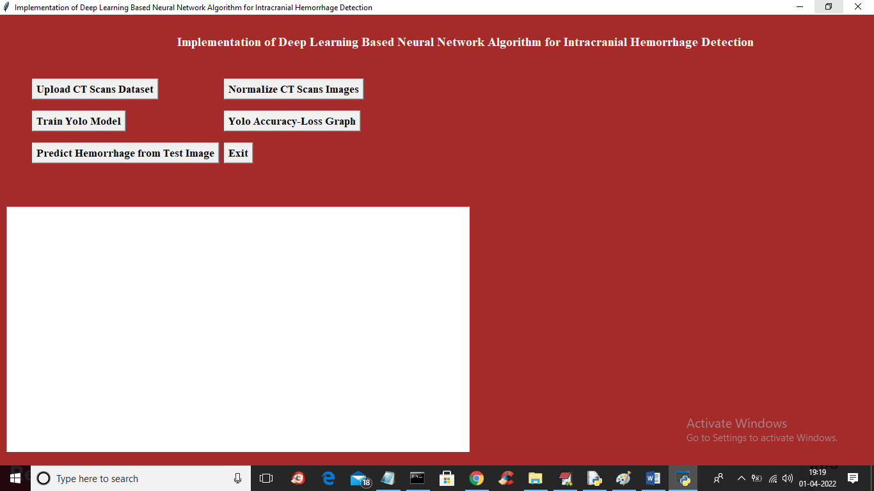
In above screen click on ‘Upload CT Scans Dataset’ button to upload dataset and to get below screen
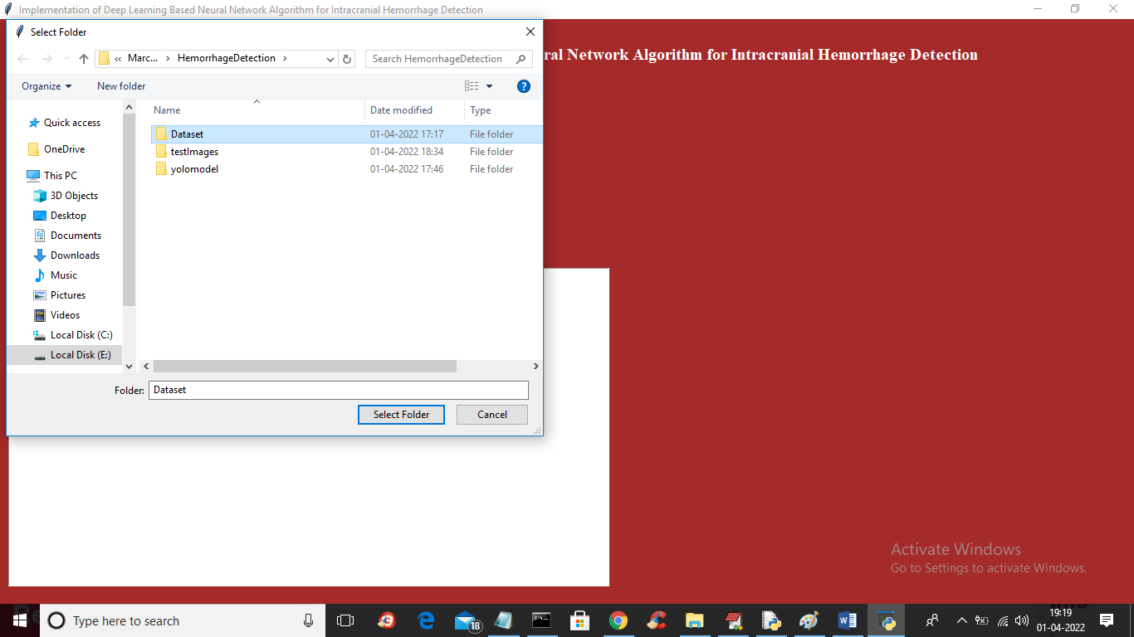
In above screen selecting and uploading ‘Dataset’ folder and then click on ‘Select Folder’ button to load dataset and to get below screen
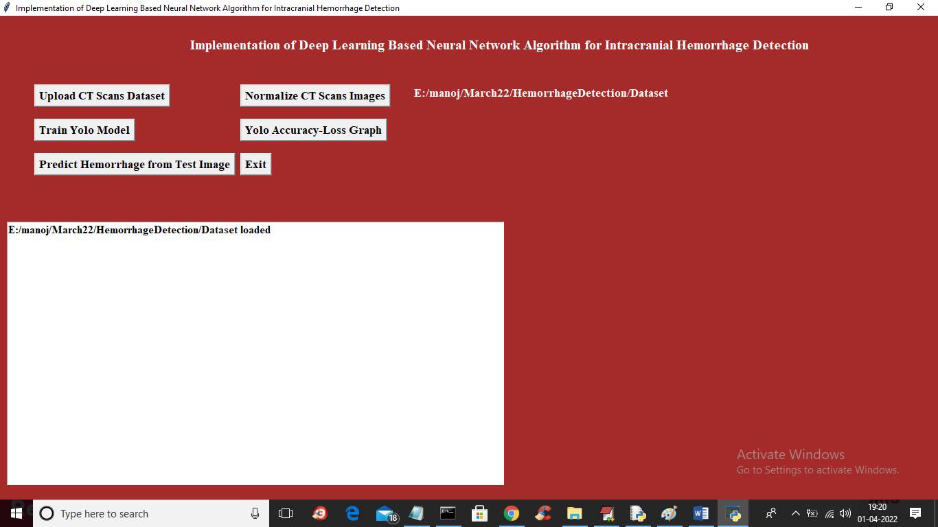
In above screen dataset loaded and now click on ‘Normalize Ct Scan Image’ button to read all images and then normalize and then split into train and test and get below output
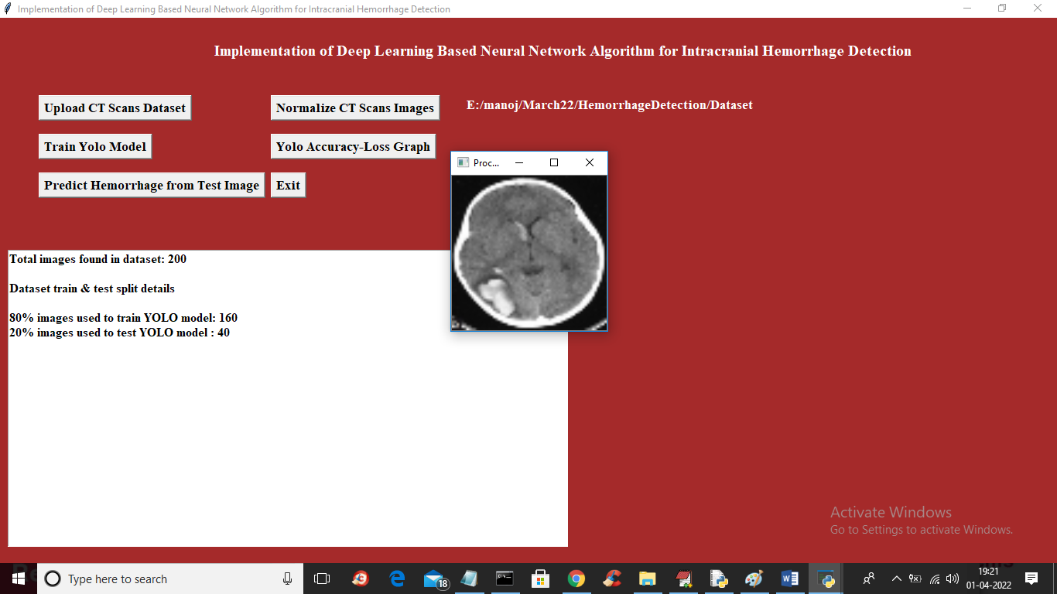
In above screen we can see dataset contains 200 images and application using 80% (160) images for training and 20% (40) images for testing and showing one sample normalize image and now close above image and then click on ‘Train Yolo Model’ button to train model and get below output
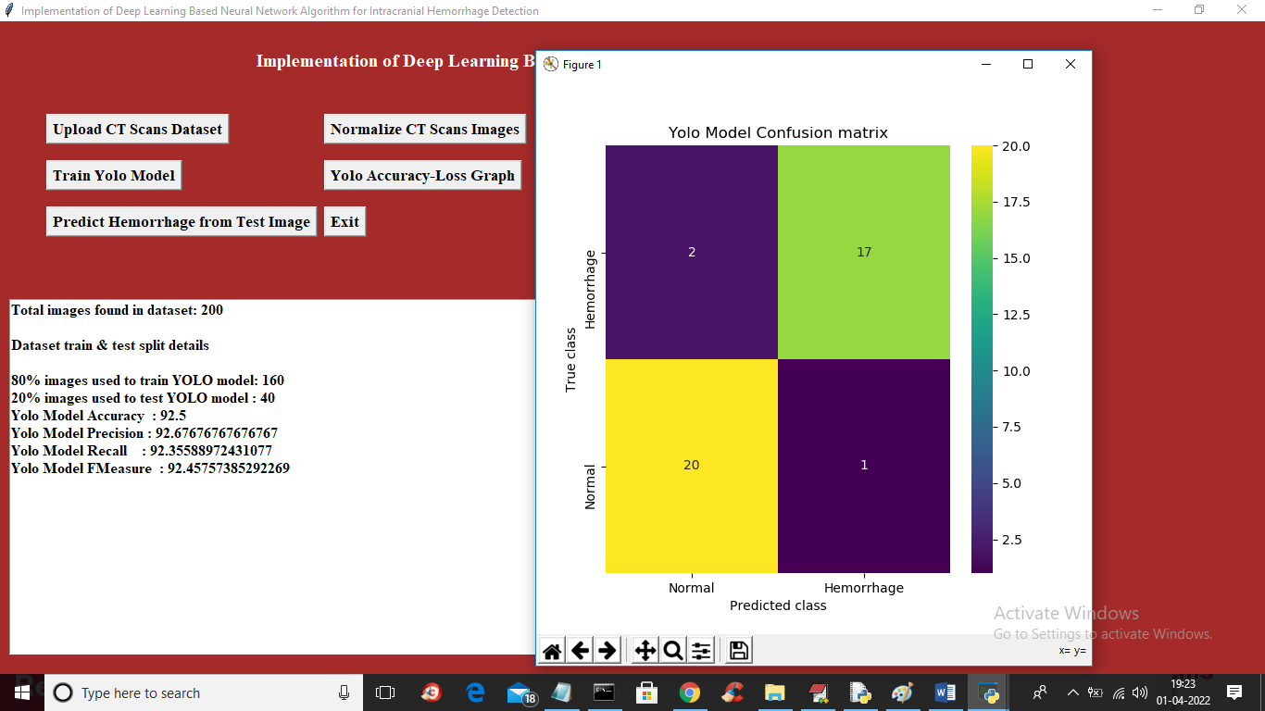
In above screen with YOLO model we got 92% accuracy and in confusion matrix x-axis represents predicted classes and y-axis represents original classes and in above graph we can see YOLO correctly predicted 20 image as Normal and only 2 images are incorrectly predicted and for Haemorrhage 17 are correctly predicted and only 1 is incorrectly predicted. Now close above graph and then click on ‘Predict Haemorrhage from Test Image’ button to upload test image recognize haemorrhage
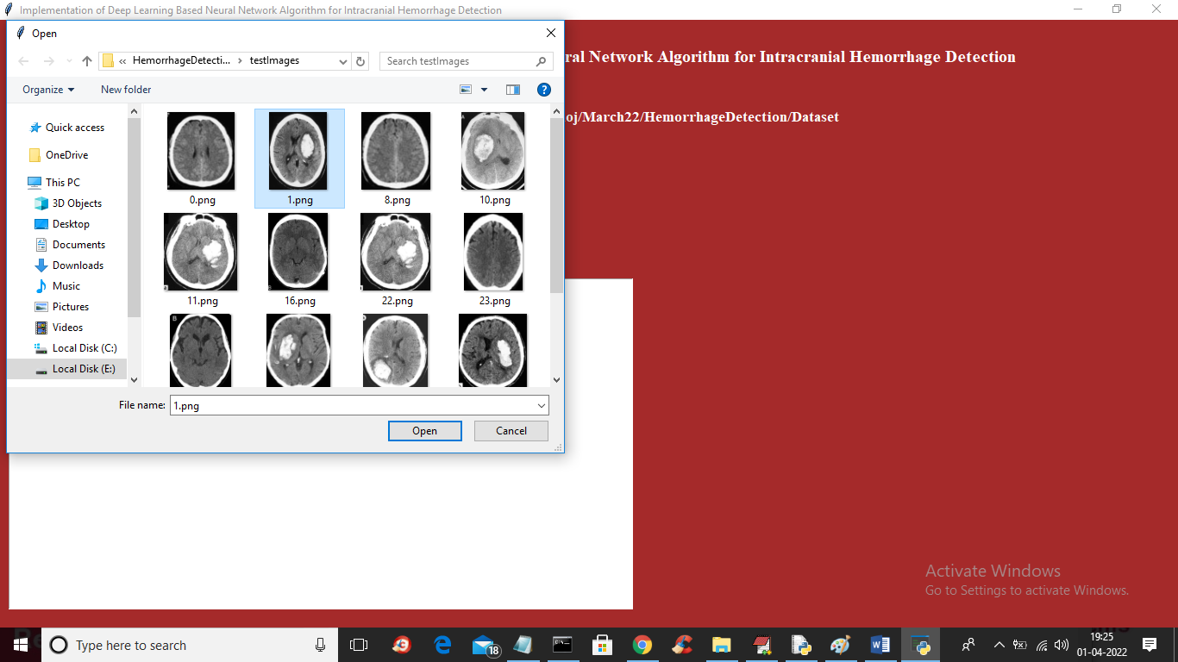
In above screen selecting and uploading 1.png and then click on ‘Open’ button to get below output
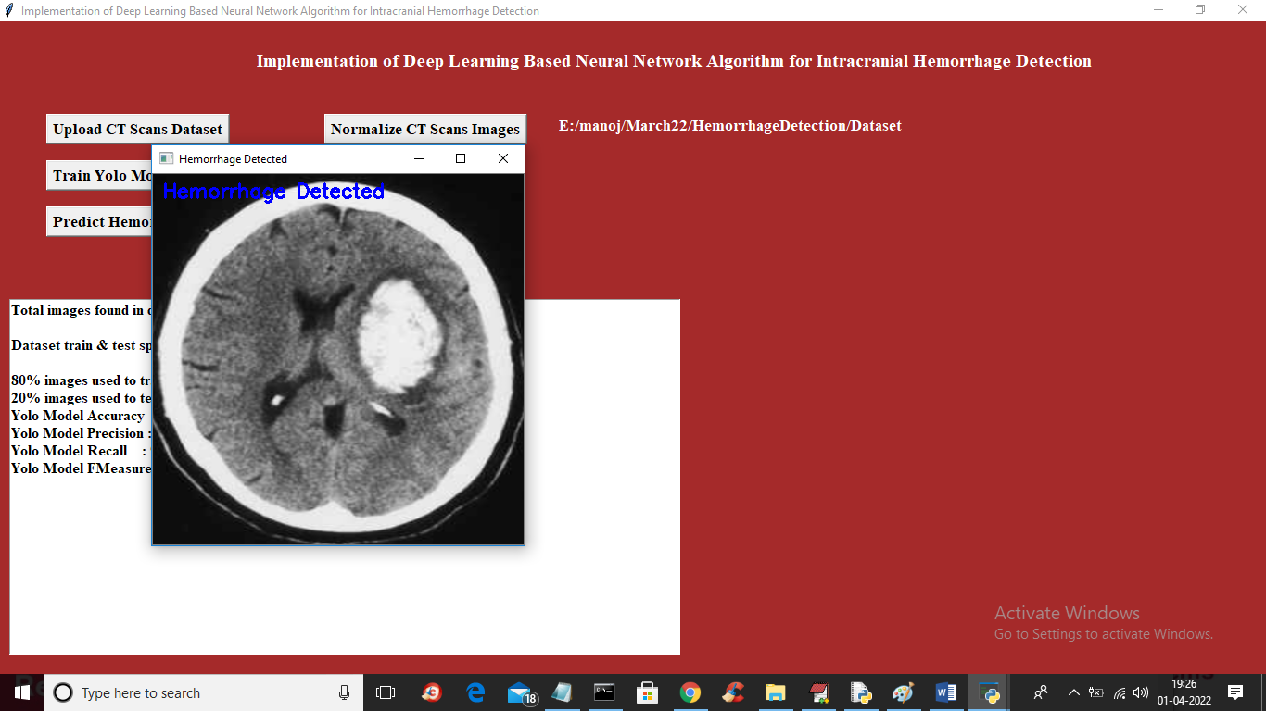
In above screen in blue colour text we can see Haemorrhage is detected and similarly you can upload and test other images
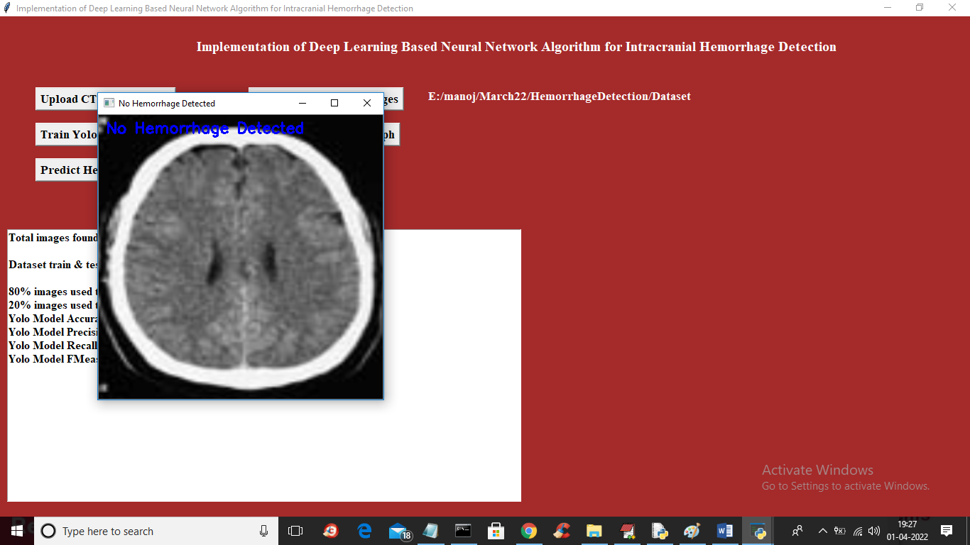
In above image NO Haemorrhage is detected
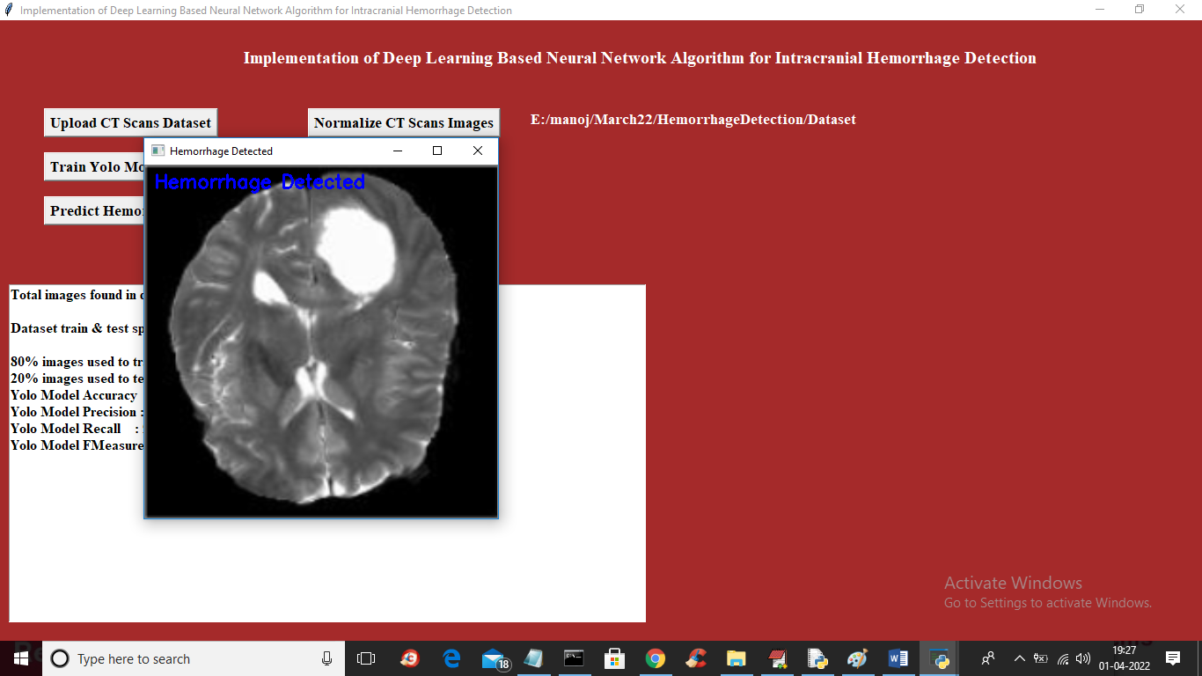
Now click on ‘Yolo Accuracy-Loss Graph’ button to get below graph
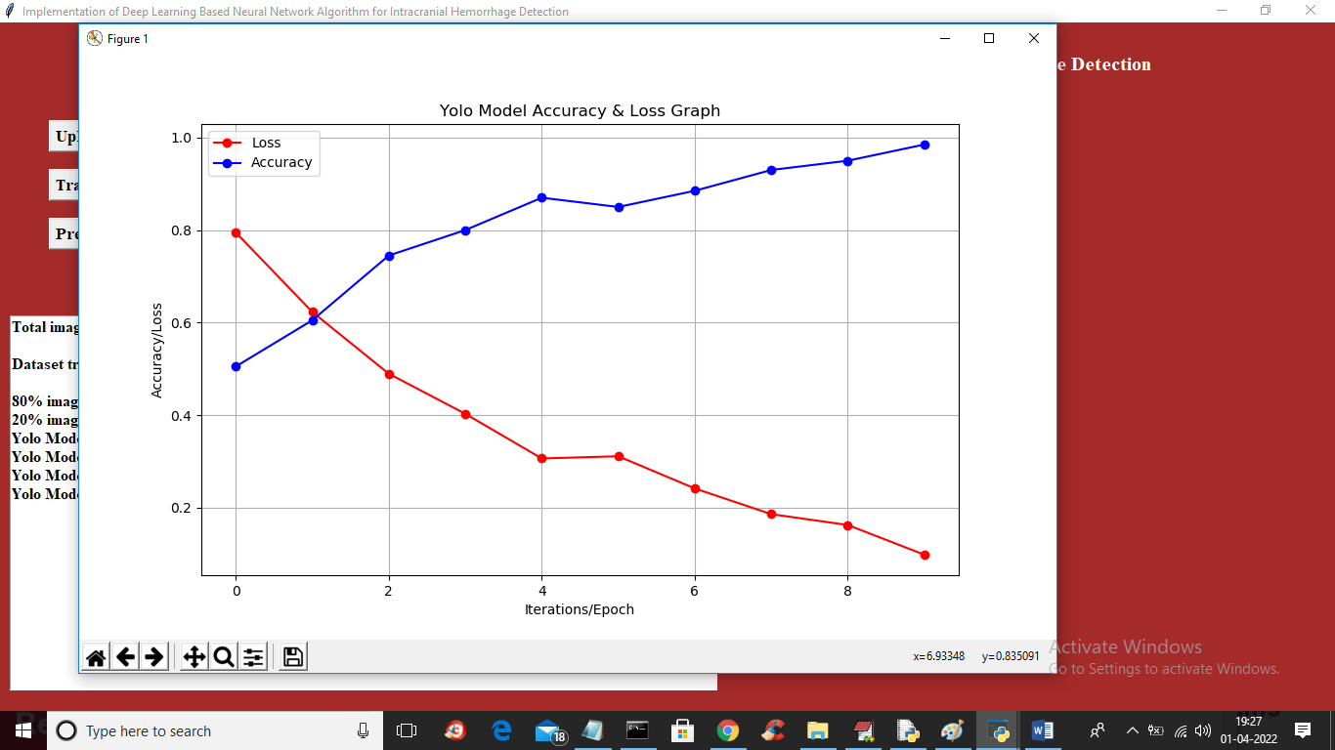
In above graph x-axis represents Epoch number and y-axis represents accuracy and loss values and in above graph blue line indicated accuracy and red line indicate LOSS and in above graph we can see with each increasing epoch accuracy got increase and loss get decrease.

8.CONCLUSION
Intracerebral Haemorrhage (ICH), a condition characterized by injury of blood vessels in brain tissues, is one of the important reasons for stroke. Images generated by X-rays and Computed Tomography (CT) are widely used for estimating the size and location of hemorrhages. Radiologists use manual planimetry, a time-consuming process for segmenting CT scan images. Deep Learning (DL) is the most preferred method to increase the efficiency of diagnosing ICH. So in this paper author using RSNA (Radiological Society of North America) based images to train YOLO deep learning model which can help in detecting and recognizing Haemorrhage and this model can get accuracy of 98% in detecting any kind of Haemorrhage.

9. REFERENCES
1. Esteva, A. et al. Dermatologist-level classification of skin cancer with deep neural networks. Nature 542, 115–118 (2017).
2. Gulshan, V. et al. Development and validation of a deep learning algorithm for detection of diabetic retinopathy in retinal fundus photographs. JAMA 316, 2402–2410 (2016).
3. Rajpurkar, P. et al. Chexnet: Radiologist-level pneumonia detection on chest X-rays with deep learning. Preprint at https://arxiv.org/abs/1711.05225 (2017).
4. Castelvecchi, D. Can we open the black box of AI? Nature 538, 20–23 (2016).
5. Clinical and Patient Decision Support Software. Draft Guidance for Industry and Food and Drug Administration Staff (US FDA, 2017).
6. Deng, J. et al. Imagenet: a large-scale hierarchical image database. In Proc. IEEE Conference on Computer Vision and Pattern Recognition 248–255 (IEEE, 2009).
7. Simonyan, K. & Zisserman, A. Very deep convolutional networks for large-scale image recognition. Preprint at https://arxiv.org/abs/1409.1556 (2014).
8. He, K., Zhang, X., Ren, S. & Sun, J. Deep residual learning for image recognition. In Proc. IEEE Conference on Computer Vision and Pattern Recognition 770–778 (IEEE, 2016).
9. Szegedy, C., Vanhoucke, V., Ioffe, S., Shlens, J. & Wojna, Z. Rethinking the inception architecture for computer vision. In Proc. IEEE Conference on Computer Vision and Pattern Recognition 2818–2826 (IEEE, 2016).

